CSA0734-COMPUTER NETWORKS FOR SERVER MANAGEMENT

NAME: SAKTHIVEL V

REG. NO.: 192211689

EXPERIMENT 14

Design of functionalities and Exploration of TCP

Aim:

To design the functionalities and Exploration of TCP.

Tools Required:

1.End device - They are the devices through which we can pass message from one device to another and they are interconnected.

2.Switch/Hub - Interface Between two devices.

3.Cable - Used to connect two devices.

Procedure:

STEP 1: Click on end devices, select generic Pc’s drag and drop it on the window. Click on SWITCH drag and drop it on the window.

**STEP** 2: Select the straight through cable and connect all end device to switch. Assign the IP address for all end devices. (Double click the end device Select →desktop → IP configuration static)

**STEP** 3: Now set the IP address to Host A (192.168.1.1) in static mode. Similarly set IP address for Host B (192.168.1.2) and Host C (192.168.1.3) and other Hosts and server.

**STEP** 4: To view the IP address, give ipconfig command in command prompt. Using ping command, we can establish communication between two host devices.

**STEP** 5: Now display the packet transmission in simulation mode.

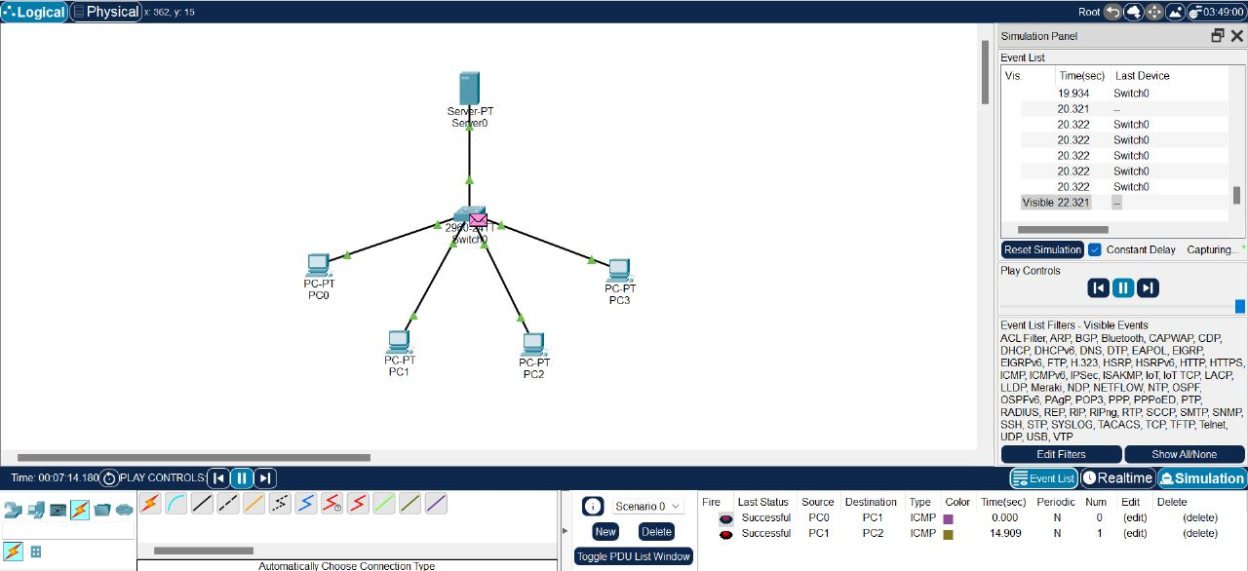

Result:

The functionalities and exploration of TCP using Packet Tracer has been executed successfully.